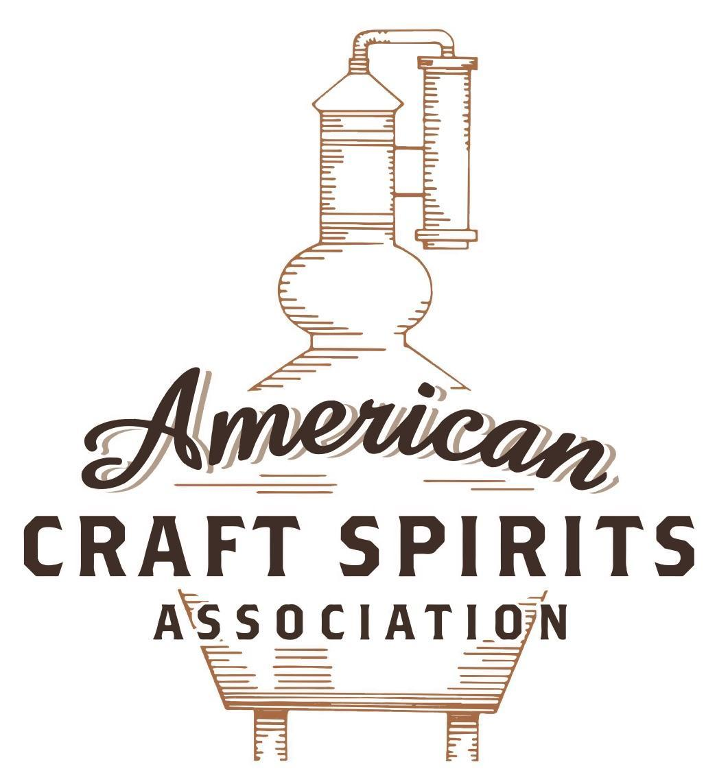
Spirits DtC Shipping Guide

This guide summarizes the direct-to-consumer shipping rules for distilleries in all 50 states and D.C. and also addresses the measures state governments have taken to ease delivery and shipping restrictions during the COVID-19 pandemic.

DtC Quick Guide Comparison

Out-of-State Distilleries  Can Ship Into State? |  |  |  | In-State Distilleries  Can Ship Within State?
State | Yes | No |  | State | Yes | No
AL |  | X |  | AL |  | X
AK | X |  |  | AK | X
AZ | X |  |  | AZ | X
AR |  | X |  | AR |  | X
CA |  | X* |  | CA |  | X*
CO |  | X |  | CO |  | X
CT |  | X* |  | CT |  | X
DE |  | X |  | DE |  | X
DC | X |  |  | DC | X
FL |  | X |  | FL |  | X
GA |  | X |  | GA |  | X
HI |  | X* |  | HI |  | ?*
ID |  | X |  | ID |  | X
IL |  | X* |  | IL |  | X*
IN |  | X |  | IN |  | X
IA |  | X* |  | IA |  | X*
KS |  | X |  | KS |  | X
KY | X |  |  | KY | X
LA |  | X |  | LA |  | X
ME |  | X* |  | ME |  | X*
MD |  | X |  | MD |  | X
MA |  | X |  | MA |  | X
MI |  | X |  | MI |  | X
MN |  | X |  | MN |  | X
MS |  | X |  | MS |  | X
MO |  | X |  | MO |  | X
MT |  | X |  | MT |  | X
NE | X |  |  | NE | X
NV |  | X* |  | NV |  | X
NH | X |  |  | NH |  | X*
NJ |  | X* |  | NJ |  | X*
NM |  | X |  | NM |  | X
NY |  | X* |  | NY |  | X*
NC |  | X |  | NC |  | X
ND | X |  |  | ND | X
OH |  | X |  | OH |  | X
OK |  | X |  | OK |  | X
OR |  | X |  | OR | X
PA |  | X* |  | PA |  | X
RI |  | X* |  | RI |  | X
SC |  | X |  | SC |  | X
SD |  | X |  | SD |  | X
TN |  | X |  | TN |  | X
TX |  | X |  | TX |  | X
UT |  | X |  | UT |  | X
VT |  | X |  | VT |  | X
VA |  | X |  | VA |  | X
WA |  | X* |  | WA | X
WV |  | X* |  | WV |  | X*

WI |  | X |  | WI |  | X
WY |  | X |  | WY |  | X

Notes:
*CA: If passed and signed into law, Senate Bill 620 would allow licensed distilled spirits producers in states other than California and licensed distilled spirits manufacturers or craft distillers in California who obtain distilled spirits direct shipper permits to ship directly to consumers in California
*CT: Consumers with appropriate permit may receive alcohol shipments
*HI: Consumers with appropriate permit may receive alcohol shipments; If passed and signed into law, Senate Bill 65 would allow licensed distilled spirits manufacturers in Hawaii and in states other than Hawaii who obtain direct shipper permits to ship directly to consumers in Hawaii
*IL: If passed and signed into law, Senate Bill 0532 would allow licensed distilled spirits producers in Illinois and in states other than Illinois who obtain distillery shippers’ licenses to ship directly to consumers in Illinois
*IA: If passed and signed into law, House File 639 would allow native distilled spirits manufacturers in Iowa and in states other than Iowa who obtain direct shipper permits to ship directly to consumers in Iowa and to consumers in states other than Iowa
*ME: If passed and signed into law, Legislative Document 1358 would allow distilleries outside of Maine with current manufacturer licenses and distilleries licensed in Maine who obtain spirits direct shipper licenses to ship directly to consumers in Maine
*NJ: (1) If passed and signed into law, Assembly Bill 3167 would allow a craft distillery licensees to ship no more than 9 liters of distilled spirits to a consumer in New Jersey; (2) If passed and signed into law, Senate Bill 3020 would allow craft distillery licensees in New Jersey or in states other than New Jersey to ship no more than 20 liters of distilled spirits to a consumer in New Jersey via common carrier
*NV: Licensed individuals can import one gallon per month of spirits for personal use and the out-of-state supplier must pay excise tax
*NH: If passed and signed into law, Senate Bill 125 would allow licensed liquor manufacturers who obtain direct to consumer shipping permits from the commission to ship directly to consumers in New Hampshire
*NY: Consumer may import up to 90L of liquor per year for personal use without a license; If passed and signed into law, Assembly Bill 3275 would allow licensed liquor manufacturers in states other than New York and licensed distillers and farm distillers in New York to ship no more than thirty-six cases (no more than nine liters per case) of liquor to consumers in New York
*PA: Consumer may place a special liquor order and distiller must ship to a PLCB-operated store
*RI: Distiller can only ship to customer if order was personally placed by customer at distiller's premises
*WA: If passed and signed into law, House Bill 1432 would allow licensed spirits manufacturers in states other than Washington to ship spirits to consumers in Washington
*WV: Distilleries, mini-distilleries, or micro-distilleries licensed in West Virginia or a state other than West Virginia who obtain private direct shipper licenses to ship to a consumer in West Virginia, however the shipments must be made to a retail liquor outlet
CONNECTICUT
Shipment Outbound – Yes, as permitted by outbound state’s law (Conn. Gen. Stat. § 30-16(a)).
Shipment Inbound – No, however, a consumer may obtain a permit to import up to 5 gallons of alcohol for personal consumption in a 60-day period (Conn. Gen. Stat. § 12-436(b)(2)(A); (B)(i)).
Shipment Intra-state – No, but a holder of a manufacturer permit for spirits who produces less than 50,000 gallons of spirits in a year may sell to customers on their premises for off-premises consumption (Conn. Gen. Stat. § 30-16(a)).
COVID-19 Measures – The state has released various COVID-19 relief measures, but none relating to manufacturers and shipment of alcohol. The relief measures concern the serving of alcohol at food establishments and avoiding consumption of alcohol in bars. These measures remained in effect through May 20, 2021.
Citation (shipment)
Conn. Gen. Stat. § 12-436. Distributor’s license. Importation of alcoholic beverages. Invoices. Shipment into military reservation.
(b) (1) No person, except a licensed distributor and railroad or airline companies so far as they conduct such beverage business in cars or passenger trains or airplanes, shall sell any alcoholic beverages in this state or possess beverages with intent to sell, unless such beverages have previously been subject to the tax imposed by this chapter.

(2) (A) Except as otherwise provided in this subdivision and sections 30-18 and 30-18a, no person shall ship, transport or import alcoholic beverages into this state unless such alcoholic beverages are delivered to a licensed distributor or to an internal revenue or United States customs bonded warehouse under regulations prescribed by the Commissioner of Revenue Services, or are transported in bonded trucks to vessels in Connecticut ports for export.

(B) (i) Any individual may import alcoholic beverages purchased by such individual within the territorial limits of the United States to an amount not to exceed five gallons in any sixty-day period for such individual's own consumption, (ii) any individual may import alcoholic beverages, whether or not purchased by such individual, from outside the territorial limits of the United States to an amount not to exceed five gallons in any three-hundred-sixty-five-day period for such individual's own consumption, and (iii) any individual who has resided outside the United States for a period of six months or more may, on one occasion and in conjunction with the return of such individual's personal and household goods and effects upon the termination of such foreign residency, import wine to an amount not to exceed one hundred gallons, of which not more than twenty gallons shall be of the same brand and spirits not to exceed ten gallons of which not more than two gallons shall be of the same brand, after making application in each such case to the Department of Revenue Services and presenting with the application a tax return prescribed by the Commissioner of Revenue Services and reporting the taxes under this chapter and under chapter 219 for which the applicant is liable. Payment of such taxes shall accompany such application and tax return. A copy of the importation certificate issued by the Department of Revenue Services shall accompany each such shipment.
Link: https://www.cga.ct.gov/current/pub/chap_220.htm#sec_12-436
Conn. Gen. Stat. § 30-16. Manufacturer permit for spirits. Manufacturer permit for beer. Manufacturer permit for a farm winery. Manufacturer permit for wine, cider and mead.
(a) A manufacturer permit for spirits shall allow the manufacture of spirits and the storage, bottling and wholesale distribution and sale of spirits manufactured or bottled to permittees in this state and without the state as may be permitted by law; but no such permit shall be granted unless the place or the plan of the place of manufacture has received the approval of the Department of Consumer Protection. The holder of a manufacturer permit for spirits who produces less than fifty thousand gallons of spirits in a calendar year may sell at retail from the premises sealed bottles or other sealed containers of spirits manufactured on the premises for consumption off the premises, provided such holder shall not sell to any one consumer more than three liters of spirits per day nor more than five gallons of spirits in any two-month period. Retail sales by a holder of a manufacturer permit for spirits shall occur only on the days and times permitted under subsection (d) of section 30-91. A holder of a manufacturer permit for spirits, alone or in combination with any parent or subsidiary business or related or affiliated party, who sells more than ten thousand gallons of spirits in any calendar year may not sell spirits at wholesale to retail permittees within this state. Such permit shall also authorize the offering and tasting, on the premises of the permittee, of free samples of spirits distilled on the premises. Such free samples of spirits distilled on the premises may be offered for consumption in combination with a nonalcoholic beverage. Tastings shall not exceed two ounces per patron per day and shall not be allowed on such premises on Sunday before eleven o'clock a.m. and after eight o'clock p.m. and on any other day before ten o'clock a.m. and after eight o'clock p.m. No tastings shall be offered to or allowed to be consumed by any minor or intoxicated person. A holder of a manufacturer permit for spirits may apply for and shall receive an out-of-state shipper's permit for manufacturing plants and warehouse locations outside the state owned by such manufacturer or a subsidiary corporation thereof, at least eighty-five per cent of the voting stock of which is owned by such manufacturer, to bring into any of its plants or warehouses in the state spirits for reprocessing, repackaging, reshipment or sale either (1) within the state to wholesaler permittees not owned or controlled by such manufacturer, or (2) outside the state. The annual fee for a manufacturer permit for spirits shall be one thousand eight hundred fifty dollars.
Link: https://www.cga.ct.gov/current/pub/chap_545.htm#sec_30-16

The American Craft Spirits Association (ACSA) is working diligently to give our members and industry partners relevant, current updates on statutes and regulations impacting production, sale and distribution of spirits. With the declaration of the novel coronavirus (COVID-19) in early 2020, many states have issued temporary policy changes or longer-term modernization of alcohol beverage laws. State statutes, regulations created by the state alcohol regulatory authority, as well as any other relevant guidance provided by such authorities (such as advisories, opinions, bulletins, etc.) were reviewed in creation of this document. No city or county ordinances were reviewed. Distillers should be aware that even in states where direct shipping is permissible, always remember to avoid shipping to dry counties. Please consult with your state guild or alcohol beverage authority for the most up-to-date information. This content is intended for educational and informational purposes only. ACSA's pro bono law firm of Malkin Law P.A. provided the core content found in this comprehensive overview of the spirits distribution after COVID-19. It was completed in August 2021 and will be updated regularly. If you have updates you would like to provide, please send to legislation@americancraftspirits.org or directly to the law firm at: ryan@malkin.law / malkin.law. Thank you.
H.B. 6100, signed and enacted into law on June 7, 2021, does not permit direct-to-consumer shipping, but the legislation allows a holder of a manufacturer permit to deliver alcoholic liquor manufactured by such permittee through June 4, 2024. A delivery must be made by a direct employee of the permittee and not by a third-party vendor or entity unless the third-party vendor or entity holds an in-state transporter’s permit. Link: https://www.cga.ct.gov/2021/ACT/PA/PDF/2021PA-00037-R00HB-06100-PA.PDF

